Yuki Matsuri

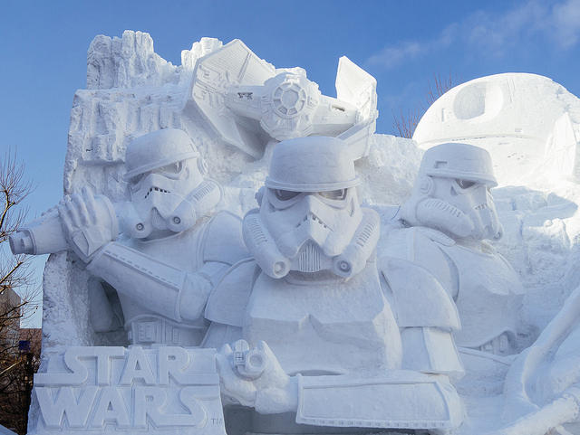

Yuki Matsuri, also known as “Sapporo snow festival”, is held for about a week in Hokkaido. This festivity is one of Japan’s most popular winter events, starting out in 1950 when a group of high-school students built snow statues in the local park. It has since developed into a huge, cultural event featuring snow and ice sculptures which people compete in by making their own, it attracts more than two million visitors from Japan and across the world every year.

The subject of the statues varies and often features an event, famous building or person from the previous year. For example, in 2004, there were statues of Hideki Matsui, the famous baseball player who at that time played for the New York Yankees. A number of stages made out of snow are also constructed and some events including musical performances are held. At the Satoland site, visitors can enjoy the long snow and ice slides as well as a huge maze made of snow. Visitors can also enjoy a variety of regional foods from all over Hokkaidō at the Odori Park and Satoland sites, such as fresh seafood, potatoes, corn, and fresh dairy products.

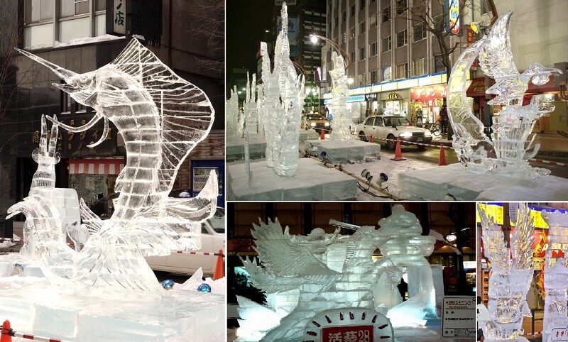

The main site is the Odori Site in Sapporo's centrally located 1.5 kilometer long Odori Park. The festival's famous large snow sculptures, some measuring more than 25 meters wide and 15 meters high, are exhibited there. They are lit up daily until 22:00.  
Besides about a dozen large snow sculptures, the Odori Site exhibits more than one hundred smaller snow statues and hosts several concerts and events, many of which use the sculptures as their stage.  
A good view over the Odori Site can be enjoyed from the Sapporo TV Tower at the eastern end of Odori Park. The tower has extended hours (8:30 to 22:30) during the festival. Admission to the top observatory deck costs 720 yen per adult. A 1100 yen ticket allows a day visit and a night visit.

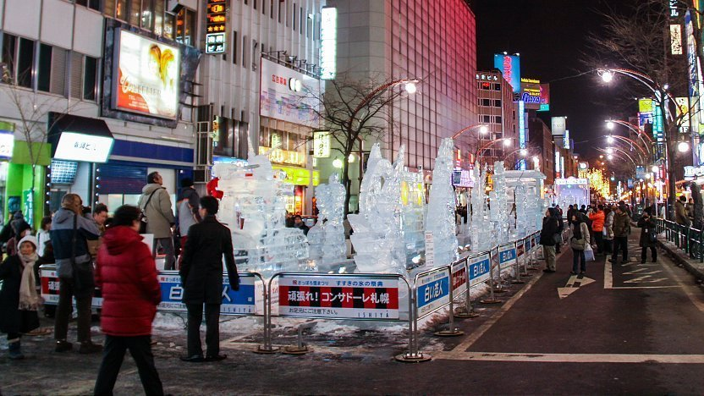

The less centrally located Tsu Dome Site is a family oriented site with three types of snow slides, snow rafting and more snow sculptures. Inside the dome, there are many food stands and a stage for events. The Tsu Dome Site is open daily from 9:00 to 17:00. The Tsu Dome Site opens a few days before the full start of the festival, on January 31, 2020.

